Ogier company need to create case study which which we have done
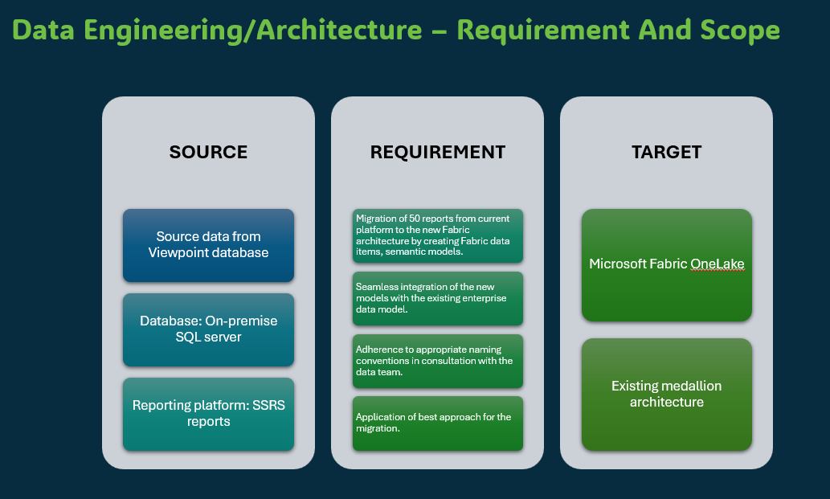
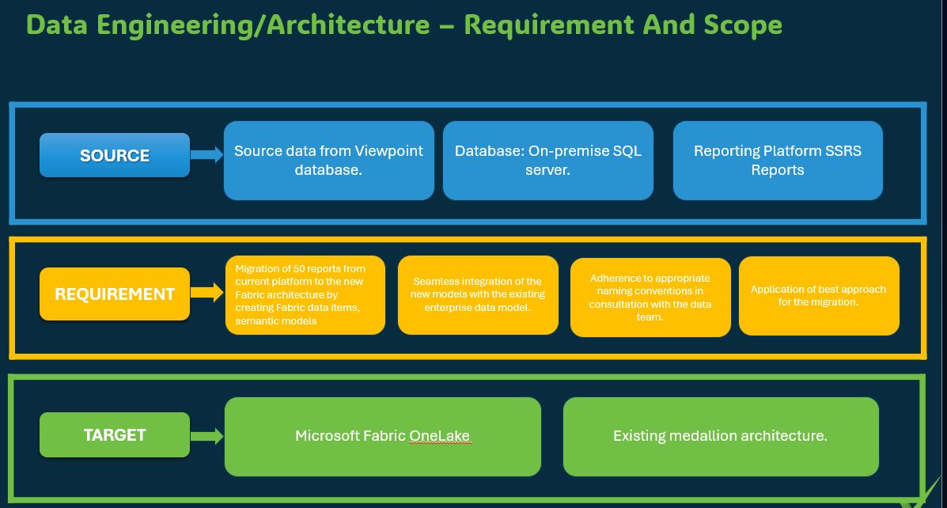
Fullfiled above requirement
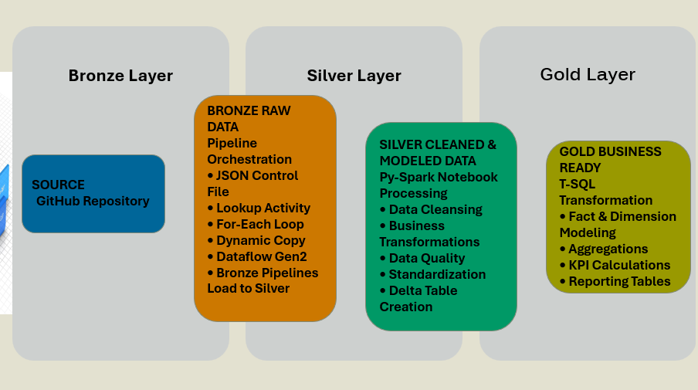
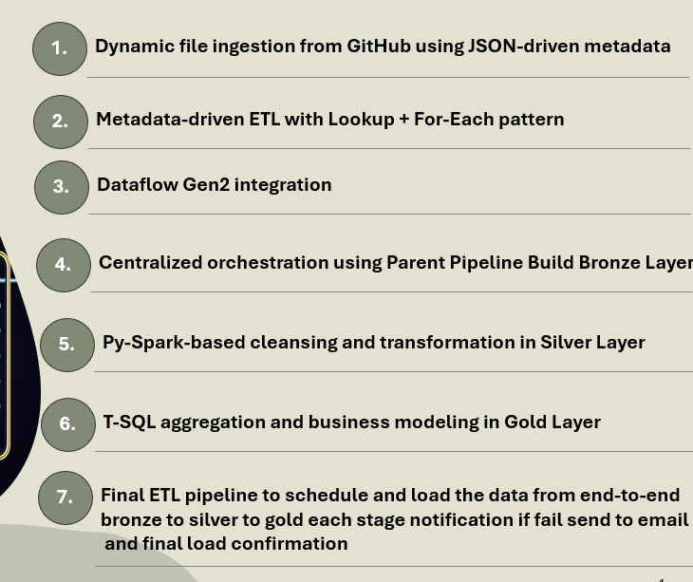
Add incremental load
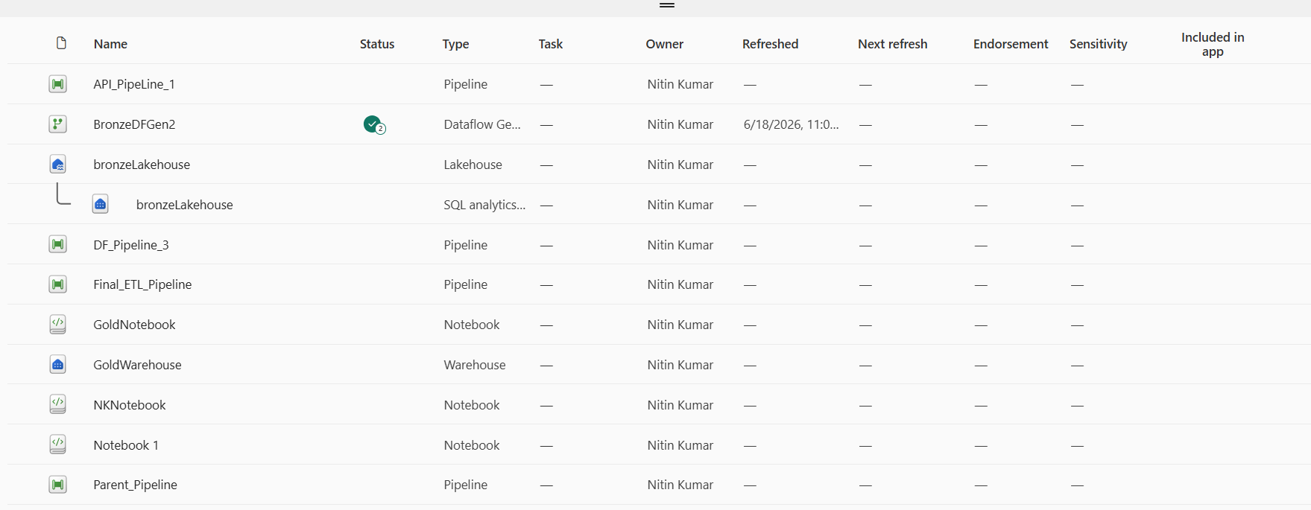
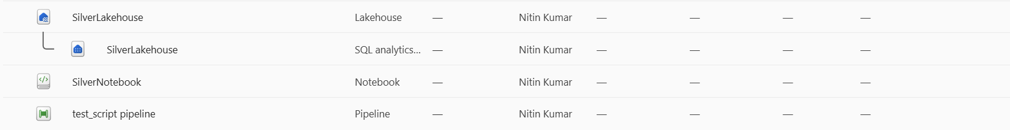
considering all these above inputs create case study just like mentioned below-
Make a note it should be similar to below case study
Client Context
A leading enterprise operating across multiple regions faced challenges with diverse data sources, manual data processing, and limited visibility into business information. The proliferation of disparate systems and increasing data volumes resulted in inconsistent reporting, delayed insights, and inefficiencies in analytics operations. The organization sought a modern, scalable data platform to establish a single source of truth and enable real-time, data-driven decision-making.
KiyaAI Approach and Solution
KiyaAI was engaged in a consulting assignment with the enterprise to first understand the existing technology and systems landscape and post this exercise, we implemented a cloud-based data modernization program leveraging Azure Data Factory and Databricks to streamline data ingestion, transformation, and analytics across the enterprise. The solution enabled the organization to build a scalable and governed data ecosystem supporting both operational and analytical workloads.
Key features included:
- Automated data ingestion from multiple source systems using Azure Data Factory.
- Scalable data transformation and processing using Databricks and Apache Spark.
- Development of centralized data lakes and curated data repositories.
- Real-time and batch data integration to support timely business insights.
- Implementation of data quality, governance, and monitoring frameworks.
- Integration with BI and reporting platforms for advanced analytics and visualization.
- Secure and scalable architecture supporting future growth and evolving business requirements.
Business Outcomes
The Azure Data Factory and Databricks platform consolidated disparate data sources into a unified and scalable ecosystem, this massively improves data availability and reliability. Automated pipelines reduced manual effort and accelerated data processing. The organization benefited from improved reporting accuracy and enhanced analytics capabilities
KiyaAI Value Delivered
KiyaAI enabled the client to establish a modern, intelligent, and scalable data platform powered by Azure Data Factory and Databricks. Through automated data integration, advanced processing capabilities, and strong governance practices,

